Jared Hobbie

I pledge my honor that I have abided by the stevens honor system

1. When transposing a matrix by individual element you must loop over every row, then every column and then every element. If you transpose by blocks you will be taking advantage of spatial locality to increase cache efficiency. You loop within a block, which will be stored in the cache as opposed to over a whole row, which may not be stored in the cache.  
   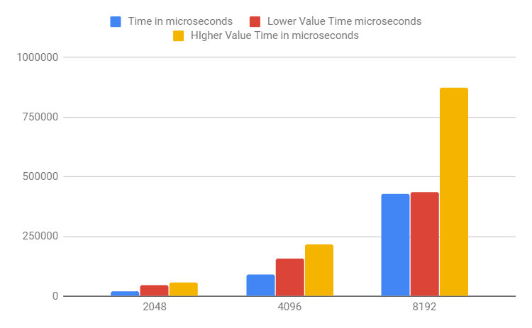  
   The best value for block width was always 8. The lower value was 2 for 2048 and 4096, but 4 for 8192, the higher value was 16 for all three.
2. 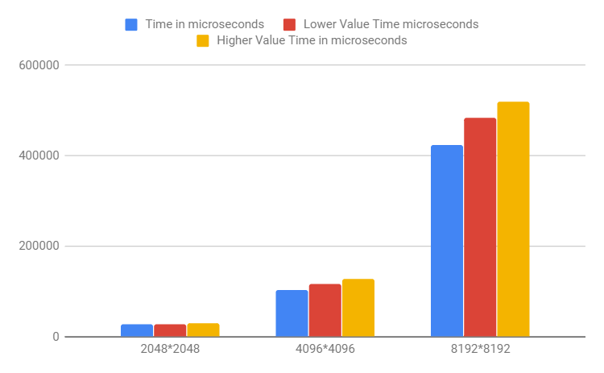

The best value for block width was always 64. The lower value was 32, the higher value was 128.

|  |  |  |  |
| --- | --- | --- | --- |
| Higher Value Time in microseconds | 30863 | 126856 | 519202 |
| Higher Value | 128 | 128 | 128 |
| Lower Value Time microseconds | 26970 | 116282 | 483598 |
| Lower Value | 32 | 32 | 32 |
| Time in microseconds | 26824 | 102920 | 424881 |
| Best Block Width | 64 | 64 | 64 |
| Input Matrix Size | 2048*2048 | 4096*4096 | 8192*8192 |